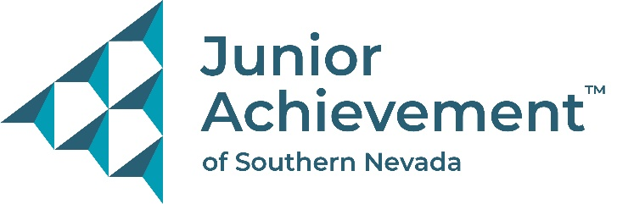

NEWS RELEASE
For Immediate Release
For More Information Contact:
Michelle Jackson, President and CEO
Junior Achievement of Southern Nevada
702-214-0503
michelle.jackson@ja.org
Junior Achievement of Southern Nevada
Announces New Board Member Ron Kullman from
Toyota Financial Savings Bank

LAS VEGAS, NV – Junior Achievement of Southern Nevada is proud to announce the addition of Ron Kullman to its board of directors. He is the Chief Risk Officer at Toyota Savings Bank and has over 25 years of experience as a financial services executive. His background includes highly regulated industries and expertise in communicating risk to all audiences from Board of Directors to C-suite officers and employee stakeholders. He successfully launched a new line of business and multiple risk management programs within complex organizations.
“We are excited to have Ron as part of our board. His passion for Junior Achievement’s mission is tried and true as shown through his personal volunteer time, and his experience and efforts in helping the community will be a great asset to our board," said Michelle Jackson, president and CEO of Junior Achievement of Southern Nevada.
Kullman has a very long history with JA starting as a classroom volunteer while at his first job with Capital One in Richmond, VA in the mid-1990s. He taught JA in classrooms in Chicago, Wilmington, DE, Bloomington, IL and now in Las Vegas.

Ron has a B.S. Business Administration in Finance and Economics from State University of New York at Fredonia and a M.B.A in Finance and Corporate Accounting from Rochester Institute of Technology.
“I’ve seen how JA can help students grow and develop life skills that will benefit them for many years to come while inspiring them to become more engaged in the classroom,” said Kullman.

About Junior Achievement of Southern Nevada
Junior Achievement of Southern Nevada, Inc. was founded locally in 1996. The organization is dedicated to providing financial education to students K-12, with a curriculum that spans from budget management to economic principals, workforce skills and credit. Junior Achievement of Southern Nevada reaches more than 20,000 students annually in the Las Vegas area with the help of 285 businesses and 6,800 business role models. For more information visit https://jasnv.org/ and follow on Instagram and Facebook.

About Junior Achievement USA® (JA)
Junior Achievement is the world's largest organization dedicated to giving young people the knowledge and skills they need to own their economic success, plan for their future, and make smart academic and economic choices. JA programs are delivered by corporate and community volunteers, and provide relevant, hands-on experiences that give students from kindergarten through high school knowledge and skills in financial literacy, work readiness and entrepreneurship. Today, JA reaches 4.5 million students per year in 115 markets across the United States, with an additional 5.8 million students served by operations in 120 other countries worldwide. Visit www.ja.org for more information.

